Creational design patterns
Creational design patterns are concerned with the way of creating objects. These design patterns are used when a decision must be made at the time of instantiation of a class (i.e. creating an object of a class).
But everyone knows an object is created by using new keyword in java. For example:
- StudentRecord s1=new StudentRecord();
Hard-Coded code is not the good programming approach. Here, we are creating the instance by using the new keyword. Sometimes, the nature of the object must be changed according to the nature of the program. In such cases, we must get the help of creational design patterns to provide more general and flexible approach.

Singleton design pattern in Java
Singleton Pattern says that just"define a class that has only one instance and provides a global point of access to it".
In other words, a class must ensure that only single instance should be created and single object can be used by all other classes.

Factory Method Pattern
A Factory Pattern or Factory Method Pattern says that just define an interface or abstract class for creating an object but let the subclasses decide which class to instantiate. In other words, subclasses are responsible to create the instance of the class.
The Factory Method Pattern is also known as Virtual Constructor.

Advantage of Factory Design Pattern
- Factory Method Pattern allows the sub-classes to choose the type of objects to create.
- It promotes the loose-coupling by eliminating the need to bind application-specific classes into the code. That means the code interacts solely with the resultant interface or abstract class, so that it will work with any classes that implement that interface or that extends that abstract class.

Usage of Factory Design Pattern
- When a class doesn't know what sub-classes will be required to create
- When a class wants that its sub-classes specify the objects to be created.
- When the parent classes choose the creation of objects to its sub-classes.
- We are going to create a Plan abstract class and concrete classes that extends the Plan abstract class. A factory class GetPlanFactory is defined as a next step.
- GenerateBill class will use GetPlanFactory to get a Plan object. It will pass information (DOMESTICPLAN / COMMERCIALPLAN / INSTITUTIONALPLAN) to GetPalnFactory to get the type of object it needs.
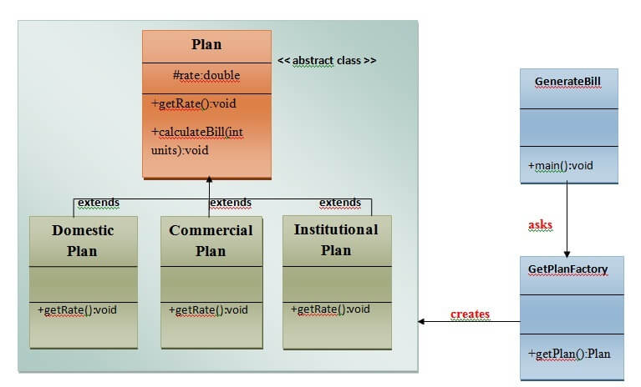

Calculate Electricity Bill : A Real World Example of Factory Method
Step 1: Create a Plan abstract class.
- import java.io.*;
- abstract class Plan{
- protected double rate;
- abstract void getRate();

- public void calculateBill(int units){
- System.out.println(units*rate);
- }
- }//end of Plan class.
Step 2: Create the concrete classes that extends Plan abstract class.
- class DomesticPlan extends Plan{
- //@override
- public void getRate(){
- rate=3.50;
- }
- }//end of DomesticPlan class.
- class CommercialPlan extends Plan{
- //@override
- public void getRate(){
- rate=7.50;
- }
- /end of CommercialPlan class.
- class InstitutionalPlan extends Plan{
- //@override
- public void getRate(){
- rate=5.50;
- }
- /end of InstitutionalPlan class.
Step 3: Create a GetPlanFactory to generate object of concrete classes based on given information..
- class GetPlanFactory{

- //use getPlan method to get object of type Plan
- public Plan getPlan(String planType){
- if(planType == null){
- return null;
- }
- if(planType.equalsIgnoreCase("DOMESTICPLAN")) {
- return new DomesticPlan();
- }
- else if(planType.equalsIgnoreCase("COMMERCIALPLAN")){
- return new CommercialPlan();
- }
- else if(planType.equalsIgnoreCase("INSTITUTIONALPLAN")) {
- return new InstitutionalPlan();
- }
- return null;
- }
- }//end of GetPlanFactory class.
Step 4: Generate Bill by using the GetPlanFactory to get the object of concrete classes by passing an information such as type of plan DOMESTICPLAN or COMMERCIALPLAN or INSTITUTIONALPLAN.
- import java.io.*;
- class GenerateBill{
- public static void main(String args[])throws IOException{
- GetPlanFactory planFactory = new GetPlanFactory();

- System.out.print("Enter the name of plan for which the bill will be generated: ");
- BufferedReader br=new BufferedReader(new InputStreamReader(System.in));

- String planName=br.readLine();
- System.out.print("Enter the number of units for bill will be calculated: ");
- int units=Integer.parseInt(br.readLine());

- Plan p = planFactory.getPlan(planName);
- //call getRate() method and calculateBill()method of DomesticPaln.

- System.out.print("Bill amount for "+planName+" of "+units+" units is: ");
- p.getRate();
- p.calculateBill(units);
- }
- }//end of GenerateBill class.

https://www.javatpoint.com/factory-method-design-pattern

Abstract Factory Pattern
Abstract Factory Pattern says that just define an interface or abstract class for creating families of related (or dependent) objects but without specifying their concrete sub-classes.That means Abstract Factory lets a class returns a factory of classes. So, this is the reason that Abstract Factory Pattern is one level higher than the Factory Pattern.
An Abstract Factory Pattern is also known as Kit.

Advantage of Abstract Factory Pattern
- Abstract Factory Pattern isolates the client code from concrete (implementation) classes.
- It eases the exchanging of object families.
- It promotes consistency among objects.

Usage of Abstract Factory Pattern
- When the system needs to be independent of how its object are created, composed, and represented.
- When the family of related objects has to be used together, then this constraint needs to be enforced.
- When you want to provide a library of objects that does not show implementations and only reveals interfaces.
- When the system needs to be configured with one of a multiple family of objects.

UML for Abstract Factory Pattern
- We are going to create a Bank interface and a Loan abstract class as well as their sub-classes.
- Then we will create AbstractFactory class as next step.
- Then after we will create concrete classes, BankFactory, and LoanFactory that will extends AbstractFactory class
- After that, AbstractFactoryPatternExample class uses the FactoryCreator to get an object of AbstractFactory class.
- See the diagram carefully which is given below:
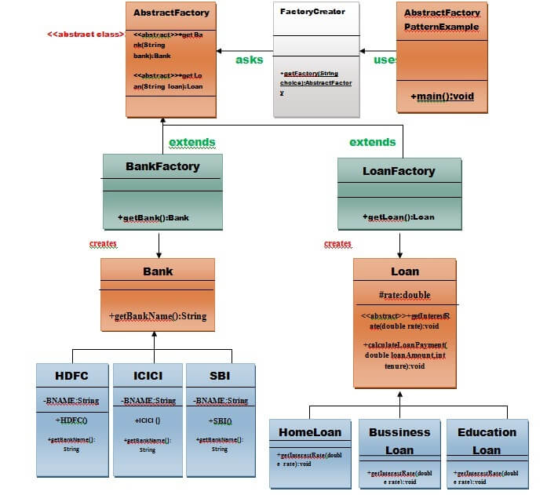

Example of Abstract Factory Pattern
Here, we are calculating the loan payment for different banks like HDFC, ICICI, SBI etc.
Step 1: Create a Bank interface
- import java.io.*;
- interface Bank{
- String getBankName();
- }
Step 2: Create concrete classes that implement the Bank interface.
- class HDFC implements Bank{
- private final String BNAME;
- public HDFC(){
- BNAME="HDFC BANK";
- }
- public String getBankName() {
- return BNAME;
- }
- }
- class ICICI implements Bank{
- private final String BNAME;
- ICICI(){
- BNAME="ICICI BANK";
- }
- public String getBankName() {
- return BNAME;
- }
- }
- class SBI implements Bank{
- private final String BNAME;
- public SBI(){
- BNAME="SBI BANK";
- }
- public String getBankName(){
- return BNAME;
- }
- }
Step 3: Create the Loan abstract class.
- abstract class Loan{
- protected double rate;
- abstract void getInterestRate(double rate);
- public void calculateLoanPayment(double loanamount, int years)
- {
- /*
- to calculate the monthly loan payment i.e. EMI

- rate=annual interest rate/12*100;
- n=number of monthly installments;
- 1year=12 months.
- so, n=years*12;

- */

- double EMI;
- int n;

- n=years*12;
- rate=rate/1200;
- EMI=((rate*Math.pow((1+rate),n))/((Math.pow((1+rate),n))-1))*loanamount;

- System.out.println("your monthly EMI is "+ EMI +" for the amount"+loanamount+" you have borrowed");
- }
- }// end of the Loan abstract class.
Step 4: Create concrete classes that extend the Loan abstract class..
- class HomeLoan extends Loan{
- public void getInterestRate(double r){
- rate=r;
- }
- }//End of the HomeLoan class.
- class BussinessLoan extends Loan{
- public void getInterestRate(double r){
- rate=r;
- }

- }//End of the BusssinessLoan class.
- class EducationLoan extends Loan{
- public void getInterestRate(double r){
- rate=r;
- }
- }//End of the EducationLoan class.
Step 5: Create an abstract class (i.e AbstractFactory) to get the factories for Bank and Loan Objects.
- abstract class AbstractFactory{
- public abstract Bank getBank(String bank);
- public abstract Loan getLoan(String loan);
- }
Step 6: Create the factory classes that inherit AbstractFactory class to generate the object of concrete class based on given information.
- class BankFactory extends AbstractFactory{
- public Bank getBank(String bank){
- if(bank == null){
- return null;
- }
- if(bank.equalsIgnoreCase("HDFC")){
- return new HDFC();
- } else if(bank.equalsIgnoreCase("ICICI")){
- return new ICICI();
- } else if(bank.equalsIgnoreCase("SBI")){
- return new SBI();
- }
- return null;
- }
- public Loan getLoan(String loan) {
- return null;
- }
- }//End of the BankFactory class.
- class LoanFactory extends AbstractFactory{
- public Bank getBank(String bank){
- return null;
- }

- public Loan getLoan(String loan){
- if(loan == null){
- return null;
- }
- if(loan.equalsIgnoreCase("Home")){
- return new HomeLoan();
- } else if(loan.equalsIgnoreCase("Business")){
- return new BussinessLoan();
- } else if(loan.equalsIgnoreCase("Education")){
- return new EducationLoan();
- }
- return null;
- }

- }
Step 7: Create a FactoryCreator class to get the factories by passing an information such as Bank or Loan.

- class FactoryCreator {
- public static AbstractFactory getFactory(String choice){
- if(choice.equalsIgnoreCase("Bank")){
- return new BankFactory();
- } else if(choice.equalsIgnoreCase("Loan")){
- return new LoanFactory();
- }
- return null;
- }
- }//End of the FactoryCreator.
Step 8: Use the FactoryCreator to get AbstractFactory in order to get factories of concrete classes by passing an information such as type.
- import java.io.*;
- class AbstractFactoryPatternExample {
- public static void main(String args[])throws IOException {

- BufferedReader br=new BufferedReader(new InputStreamReader(System.in));

- System.out.print("Enter the name of Bank from where you want to take loan amount: ");
- String bankName=br.readLine();

- System.out.print("\n");
- System.out.print("Enter the type of loan e.g. home loan or business loan or education loan : ");

- String loanName=br.readLine();
- AbstractFactory bankFactory = FactoryCreator.getFactory("Bank");
- Bank b=bankFactory.getBank(bankName);

- System.out.print("\n");
- System.out.print("Enter the interest rate for "+b.getBankName()+ ": ");

- double rate=Double.parseDouble(br.readLine());
- System.out.print("\n");
- System.out.print("Enter the loan amount you want to take: ");

- double loanAmount=Double.parseDouble(br.readLine());
- System.out.print("\n");
- System.out.print("Enter the number of years to pay your entire loan amount: ");
- int years=Integer.parseInt(br.readLine());

- System.out.print("\n");
- System.out.println("you are taking the loan from "+ b.getBankName());

- AbstractFactory loanFactory = FactoryCreator.getFactory("Loan");
- Loan l=loanFactory.getLoan(loanName);
- l.getInterestRate(rate);
- l.calculateLoanPayment(loanAmount,years);
- }
- }//End of the AbstractFactoryPatternExample

Builder Design Pattern
Builder Pattern says that "construct a complex object from simple objects using step-by-step approach"
It is mostly used when object can't be created in single step like in the de-serialization of a complex object.

Advantage of Builder Design Pattern
The main advantages of Builder Pattern are as follows:
- It provides clear separation between the construction and representation of an object.
- It provides better control over construction process.
- It supports to change the internal representation of objects.

UML for Builder Pattern Example
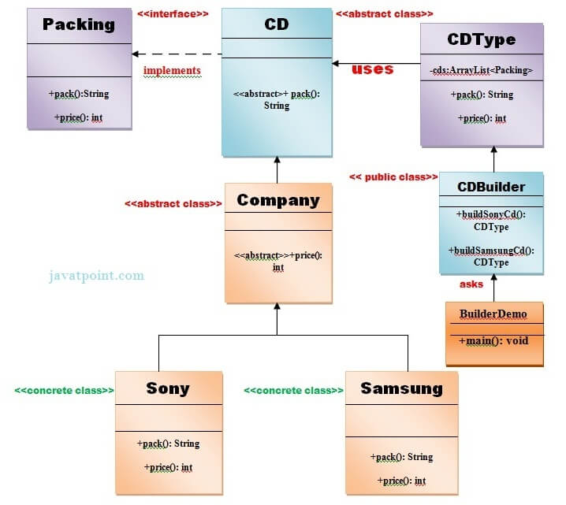

Example of Builder Design Pattern

public class Pizza {
private String dough; // required
private String sauce; // required
private String topping; // optional

// Private constructor to enforce object creation through Builder
private Pizza(PizzaBuilder builder) {
this.dough = builder.dough;
this.sauce = builder.sauce;
this.topping = builder.topping;
}

@Override
public String toString() {
return "Pizza [dough=" + dough + ", sauce=" + sauce + ", topping=" + topping + "]";
}

// Static nested Builder class
public static class PizzaBuilder {
private String dough; // required
private String sauce; // required
private String topping; // optional

// Constructor for required parameters
public PizzaBuilder(String dough, String sauce) {
this.dough = dough;
this.sauce = sauce;
}

// Method to set optional topping
public PizzaBuilder topping(String topping) {
this.topping = topping;
return this;
}

// Build method to create Pizza instance
public Pizza build() {
return new Pizza(this);
}
}
}

Prototype Design Pattern
Prototype Pattern says that cloning of an existing object instead of creating new one and can also be customized as per the requirement.
This pattern should be followed, if the cost of creating a new object is expensive and resource intensive.

Advantage of Prototype Pattern
The main advantages of prototype pattern are as follows:
- It reduces the need of sub-classing.
- It hides complexities of creating objects.
- The clients can get new objects without knowing which type of object it will be.
- It lets you add or remove objects at runtime.

Usage of Prototype Pattern
- When the classes are instantiated at runtime.
- When the cost of creating an object is expensive or complicated.
- When you want to keep the number of classes in an application minimum.
- When the client application needs to be unaware of object creation and representation.

UML for Prototype Pattern
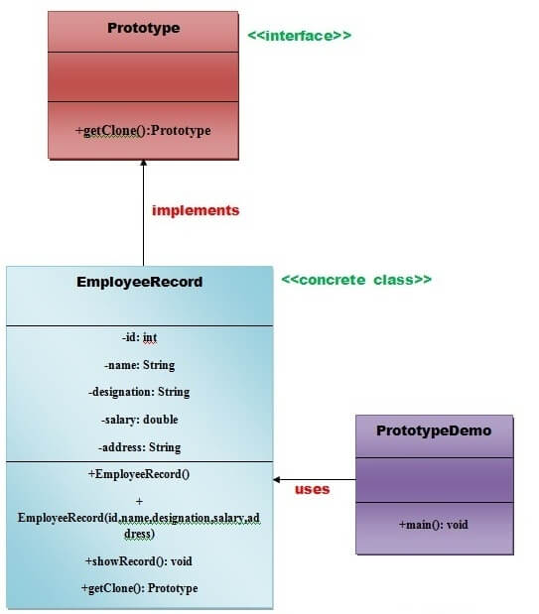
ADVERTISEMENT
- We are going to create an interface Prototype that contains a method getClone() of Prototype type.
- Then, we create a concrete class EmployeeRecord which implements Prototype interface that does the cloning of EmployeeRecord object.
- PrototypeDemo class will uses this concrete class EmployeeRecord.

Example of Prototype Design Pattern

- Example of the Prototype Design Pattern in Java
Let's create a simple example with a Shape interface and two concrete prototypes: Circle and Square.
- 1. Prototype Interface
java
Copy code
public interface Shape {
Shape clone(); // Method to clone the shape
void draw(); // Method to draw the shape
}
- 2. Concrete Prototype Classes
java
Copy code
public class Circle implements Shape {
private String type = "Circle";

@Override
public Shape clone() {
return new Circle(); // Create a new instance of Circle
}

@Override
public void draw() {
System.out.println("Drawing a " + type);
}
}

public class Square implements Shape {
private String type = "Square";

@Override
public Shape clone() {
return new Square(); // Create a new instance of Square
}

@Override
public void draw() {
System.out.println("Drawing a " + type);
}
}
- 3. Client Code
The client code demonstrates how to use the prototype pattern to create new objects:
java
Copy code
public class PrototypePatternExample {
public static void main(String[] args) {
// Create a prototype registry
Shape circlePrototype = new Circle();
Shape squarePrototype = new Square();

// Clone the shapes
Shape clonedCircle = circlePrototype.clone();
Shape clonedSquare = squarePrototype.clone();

// Draw the cloned shapes
clonedCircle.draw(); // Output: Drawing a Circle
clonedSquare.draw(); // Output: Drawing a Square
}
}
- Output:
css
Copy code
Drawing a Circle
Drawing a Square
- Explanation of the Code:
- Prototype Interface:
  - The Shape interface defines a method clone() for cloning the shape and a draw() method to display the shape.
- Concrete Prototypes:
  - The Circle and Square classes implement the Shape interface.
  - Each concrete prototype implements the clone() method, which creates a new instance of itself, effectively copying its state (in this case, they don’t have additional state to copy, but this could be expanded).
  - The draw() method outputs a message indicating the type of shape being drawn.
- Client Code:
  - The client creates instances of the concrete prototypes (Circle and Square).
  - It uses the clone() method to create new instances of these shapes.
  - Finally, it calls the draw() method on the cloned shapes to demonstrate that they work as expected.
- Benefits of the Prototype Design Pattern:
- Reduced Cost of Object Creation: By cloning existing objects, you can save on the overhead of creating new instances, especially if the construction of an object is resource-intensive.
- Flexibility: You can create new objects at runtime without knowing their concrete classes.
- Avoiding Subclassing: This pattern can be useful for avoiding an explosion of subclasses in cases where the variations are too numerous.

Singleton design pattern in Java
Singleton Pattern says that just"define a class that has only one instance and provides a global point of access to it".
In other words, a class must ensure that only single instance should be created and single object can be used by all other classes.
There are two forms of singleton design pattern
- Early Instantiation: creation of instance at load time.
- Lazy Instantiation: creation of instance when required.
import java.io.Serializable;

public class Singleton implements Serializable {

// The volatile keyword ensures that multiple threads handle the uniqueInstance variable correctly.
private static volatile Singleton uniqueInstance;

// Private constructor to prevent instantiation from other classes.
private Singleton() {
// Preventing reflection
if (uniqueInstance != null) {
throw new IllegalStateException("Instance already created. Use getInstance() method.");
}
}

// Double-checked locking for thread-safe Singleton instance creation
public static Singleton getInstance() {
if (uniqueInstance == null) { // First check (no locking)
synchronized (Singleton.class) {
if (uniqueInstance == null) { // Second check (with locking)
uniqueInstance = new Singleton();
}
}
}
return uniqueInstance;
}

// Implement readResolve to handle serialization
protected Object readResolve() {
return getInstance(); // Return the existing instance on deserialization
}

// Prevent cloning
@Override
protected Object clone() throws CloneNotSupportedException {
throw new CloneNotSupportedException("Cloning of Singleton is not allowed.");
}

// Method to demonstrate Singleton functionality
public void showMessage() {
System.out.println("Hello from Singleton!");
}
}

Structural design patterns
Structural design patterns are concerned with how classes and objects can be composed, to form larger structures.
The structural design patterns simplifies the structure by identifying the relationships.
These patterns focus on, how the classes inherit from each other and how they are composed from other classes.

Types of structural design patterns
There are following 7 types of structural design patterns.
- Adapter Pattern
Adapting an interface into another according to client expectation.
- Bridge Pattern
Separating abstraction (interface) from implementation.
- Composite Pattern
Allowing clients to operate on hierarchy of objects.
- Decorator Pattern
Adding functionality to an object dynamically.
- Facade Pattern
Providing an interface to a set of interfaces.
- Flyweight Pattern
Reusing an object by sharing it.
- proxy Pattern
Representing another object.

Adapter Pattern
An Adapter Pattern says that just "converts the interface of a class into another interface that a client wants".
In other words, to provide the interface according to client requirement while using the services of a class with a different interface.
The Adapter Pattern is also known as Wrapper.

Advantage of Adapter Pattern
- It allows two or more previously incompatible objects to interact.
- It allows reusability of existing functionality.
- Example:
- Suppose you have a Bird class with fly() , and makeSound()methods. And also a ToyDuck class with squeak() method. Let’s assume that you are short on ToyDuck objects and you would like to use Bird objects in their place. Birds have some similar functionality but implement a different interface, so we can’t use them directly. So we will use adapter pattern. Here our client would be ToyDuck and adaptee would be Bird.
- Below is Java implementation of it.
// Java implementation of Adapter pattern

interface Bird
{
// birds implement Bird interface that allows
// them to fly and make sounds adaptee interface
public void fly();
public void makeSound();
}

class Sparrow implements Bird
{
// a concrete implementation of bird
public void fly()
{
System.out.println("Flying");
}
public void makeSound()
{
System.out.println("Chirp Chirp");
}
}

interface ToyDuck
{
// target interface
// toyducks dont fly they just make
// squeaking sound
public void squeak();
}

class PlasticToyDuck implements ToyDuck
{
public void squeak()
{
System.out.println("Squeak");
}
}

class BirdAdapter implements ToyDuck
{
// You need to implement the interface your
// client expects to use.
Bird bird;
public BirdAdapter(Bird bird)
{
// we need reference to the object we
// are adapting
this.bird = bird;
}

public void squeak()
{
// translate the methods appropriately
bird.makeSound();
}
}

class Main
{
public static void main(String args[])
{
Sparrow sparrow = new Sparrow();
ToyDuck toyDuck = new PlasticToyDuck();

// Wrap a bird in a birdAdapter so that it
// behaves like toy duck
ToyDuck birdAdapter = new BirdAdapter(sparrow);

System.out.println("Sparrow...");
sparrow.fly();
sparrow.makeSound();

System.out.println("ToyDuck...");
toyDuck.squeak();

// toy duck behaving like a bird
System.out.println("BirdAdapter...");
birdAdapter.squeak();
}
}
- Output:
- Sparrow...
- Flying
- Chirp Chirp
- ToyDuck...
- Squeak
- BirdAdapter...
- Chirp Chirp
- Explanation :
Suppose we have a bird that can makeSound(), and we have a plastic toy duck that can squeak(). Now suppose our client changes the requirement and he wants the toyDuck to makeSound than ?
Simple solution is that we will just change the implementation class to the new adapter class and tell the client to pass the instance of the bird(which wants to squeak()) to that class.
Before : ToyDuck toyDuck = new PlasticToyDuck();
After : ToyDuck toyDuck = new BirdAdapter(sparrow);
You can see that by changing just one line the toyDuck can now do Chirp Chirp !!

Bridge Pattern
A Bridge Pattern says that just "decouple the functional abstraction from the implementation so that the two can vary independently".
The Bridge Pattern is also known as Handle or Body.

Advantage of Bridge Pattern
- It enables the separation of implementation from the interface.
- It improves the extensibility.
- It allows the hiding of implementation details from the client.

Usage of Bridge Pattern
- When you don't want a permanent binding between the functional abstraction and its implementation.
- When both the functional abstraction and its implementation need to extended using sub-classes.
- It is mostly used in those places where changes are made in the implementation does not affect the clients.

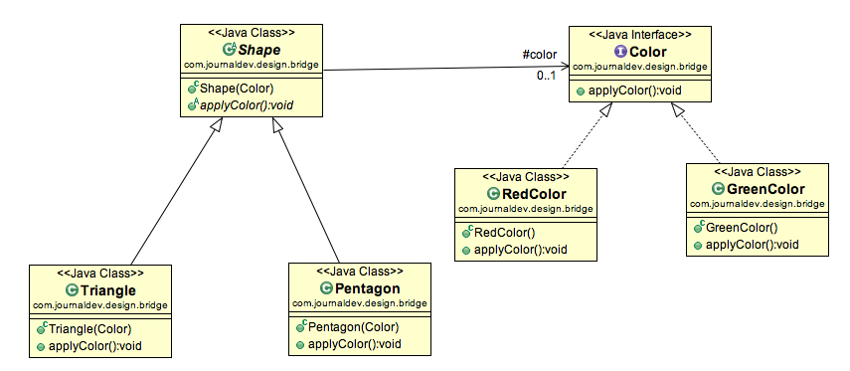

Bridge Design Pattern in Java Example
If we look into bridge design pattern with example, it will be easy to understand. Lets say we have an interface hierarchy in both interfaces and implementations like below image.
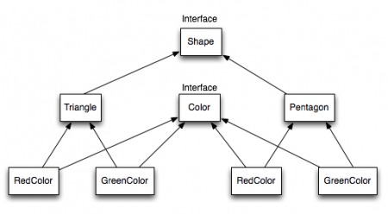
Now we will use bridge design pattern to decouple the interfaces from implementation. UML diagram for the classes and interfaces after applying bridge pattern will look like below image.
Notice the bridge between Shape and Color interfaces and use of composition in implementing the bridge pattern.
Here is the java code for Shape and Color interfaces.

package com.journaldev.design.bridge;

public interface Color {

public void applyColor();
}
Shape.java

package com.journaldev.design.bridge;

public abstract class Shape {
//Composition - implementor
protected Color color;

//constructor with implementor as input argument
public Shape(Color c){
this.color=c;
}

abstract public void applyColor();
}
We have Triangle and Pentagon implementation classes as below.
Triangle.java

package com.journaldev.design.bridge;

public class Triangle extends Shape{

public Triangle(Color c) {
super(c);
}

@Override
public void applyColor() {
System.out.print("Triangle filled with color ");
color.applyColor();
}

}
Pentagon.java

package com.journaldev.design.bridge;

public class Pentagon extends Shape{

public Pentagon(Color c) {
super(c);
}

@Override
public void applyColor() {
System.out.print("Pentagon filled with color ");
color.applyColor();
}

}
Here are the implementation classes for RedColor and GreenColor.
RedColor.java

package com.journaldev.design.bridge;

public class RedColor implements Color{

public void applyColor(){
System.out.println("red.");
}
}
GreenColor.java

package com.journaldev.design.bridge;

public class GreenColor implements Color{

public void applyColor(){
System.out.println("green.");
}
}
Lets test our bridge pattern implementation with a test program.
BridgePatternTest.java

package com.journaldev.design.test;

import com.journaldev.design.bridge.GreenColor;
import com.journaldev.design.bridge.Pentagon;
import com.journaldev.design.bridge.RedColor;
import com.journaldev.design.bridge.Shape;
import com.journaldev.design.bridge.Triangle;

public class BridgePatternTest {

public static void main(String[] args) {
Shape tri = new Triangle(new RedColor());
tri.applyColor();

Shape pent = new Pentagon(new GreenColor());
pent.applyColor();
}

}
Output of above bridge pattern example program is:

Triangle filled with color red.
Pentagon filled with color green.

Decorator Pattern
A Decorator Pattern says that just "attach a flexible additional responsibilities to an object dynamically".
In other words, The Decorator Pattern uses composition instead of inheritance to extend the functionality of an object at runtime.
The Decorator Pattern is also known as Wrapper.

Advantage of Decorator Pattern
- It provides greater flexibility than static inheritance.
- It enhances the extensibility of the object, because changes are made by coding new classes.
- It simplifies the coding by allowing you to develop a series of functionality from targeted classes instead of coding all of the behavior into the object.

Usage of Decorator Pattern
It is used:
- When you want to transparently and dynamically add responsibilities to objects without affecting other objects.
- When you want to add responsibilities to an object that you may want to change in future.
- Extending functionality by sub-classing is no longer practical.
Step 1:Create a Food interface.
- public interface Food {
- public String prepareFood();
- public double foodPrice();
- }// End of the Food interface.
Step 2: Create a VegFood class that will implements the Food interface and override its all methods.
File: VegFood.java
- public class VegFood implements Food {
- public String prepareFood(){
- return "Veg Food";
- }

- public double foodPrice(){
- return 50.0;
- }
- }
Step 3:Create a FoodDecorator abstract class that will implements the Food interface and override it's all methods and it has the ability to decorate some more foods.
File: FoodDecorator.java
- public abstract class FoodDecorator implements Food{
- private Food newFood;
- public FoodDecorator(Food newFood) {
- this.newFood=newFood;
- }
- @Override
- public String prepareFood(){
- return newFood.prepareFood();
- }
- public double foodPrice(){
- return newFood.foodPrice();
- }
- }
Step 4:Create a NonVegFood concrete class that will extend the FoodDecorator class and override it's all methods.
ADVERTISEMENT
File: NonVegFood.java
- public class NonVegFood extends FoodDecorator{
- public NonVegFood(Food newFood) {
- super(newFood);
- }
- public String prepareFood(){
- return super.prepareFood() +" With Roasted Chiken and Chiken Curry ";
- }
- public double foodPrice() {
- return super.foodPrice()+150.0;
- }
- }
Step 5:Create a ChineeseFood concrete class that will extend the FoodDecorator class and override it's all methods.
File: ChineeseFood.java
- public class ChineeseFood extends FoodDecorator{
- public ChineeseFood(Food newFood) {
- super(newFood);
- }
- public String prepareFood(){
- return super.prepareFood() +" With Fried Rice and Manchurian ";
- }
- public double foodPrice() {
- return super.foodPrice()+65.0;
- }
- }
Step 6:Create a DecoratorPatternCustomer class that will use Food interface to use which type of food customer wants means (Decorates).
File: DecoratorPatternCustomer.java
- import java.io.BufferedReader;
- import java.io.IOException;
- import java.io.InputStreamReader;
- public class DecoratorPatternCustomer {
- private static int choice;
- public static void main(String args[]) throws NumberFormatException, IOException {
- do{
- System.out.print("========= Food Menu ============ \n");
- System.out.print(" 1. Vegetarian Food. \n");
- System.out.print(" 2. Non-Vegetarian Food.\n");
- System.out.print(" 3. Chineese Food. \n");
- System.out.print(" 4. Exit \n");
- System.out.print("Enter your choice: ");
- BufferedReader br=new BufferedReader(new InputStreamReader(System.in));
- choice=Integer.parseInt(br.readLine());
- switch (choice) {
- case 1:{
- VegFood vf=new VegFood();
- System.out.println(vf.prepareFood());
- System.out.println( vf.foodPrice());
- }
- break;

- case 2:{
- Food f1=new NonVegFood((Food) new VegFood());
- System.out.println(f1.prepareFood());
- System.out.println( f1.foodPrice());
- }
- break;
- case 3:{
- Food f2=new ChineeseFood((Food) new VegFood());
- System.out.println(f2.prepareFood());
- System.out.println( f2.foodPrice());
- }
- break;

- default:{
- System.out.println("Other than these no food available");
- }
- return;
- }//end of switch

- }while(choice!=4);
- }
- }

https://www.javatpoint.com/decorator-pattern
or read from book

Facade Pattern
A Facade Pattern says that just "just provide a unified and simplified interface to a set of interfaces in a subsystem, therefore it hides the complexities of the subsystem from the client".

In other words, Facade Pattern describes a higher-level interface that makes the sub-system easier to use.
Practically, every Abstract Factory is a type of Facade.

Advantage of Facade Pattern
- It shields the clients from the complexities of the sub-system components.
- It promotes loose coupling between subsystems and its clients.

Usage of Facade Pattern:
It is used:
- When you want to provide simple interface to a complex sub-system.
- When several dependencies exist between clients and the implementation classes of an abstraction.
- Let's understand the example of facade design pattern by the above UML diagram.

UML for Facade Pattern:
- 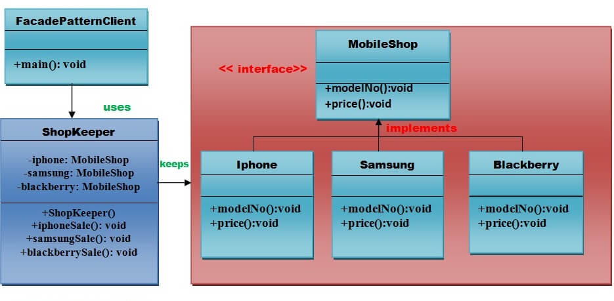

Implementation of above UML:

Step 1
Create a MobileShop interface.
File: MobileShop.java
- public interface MobileShop {
- public void modelNo();
- public void price();
- }

Step 2
Create a Iphone implementation class that will implement Mobileshop interface.
File: Iphone.java
- public class Iphone implements MobileShop {
- @Override
- public void modelNo() {
- System.out.println(" Iphone 6 ");
- }
- @Override
- public void price() {
- System.out.println(" Rs 65000.00 ");
- }
- }

Step 3
Create a Samsung implementation class that will implement Mobileshop interface.
ADVERTISEMENT
File: Samsung.java
- public class Samsung implements MobileShop {
- @Override
- public void modelNo() {
- System.out.println(" Samsung galaxy tab 3 ");
- }
- @Override
- public void price() {
- System.out.println(" Rs 45000.00 ");
- }
- }

Step 4
Create a Blackberry implementation class that will implement Mobileshop interface .
File: Blackberry.java
- public class Blackberry implements MobileShop {
- @Override
- public void modelNo() {
- System.out.println(" Blackberry Z10 ");
- }
- @Override
- public void price() {
- System.out.println(" Rs 55000.00 ");
- }
- }

Step 5
Create a ShopKeeper concrete class that will use MobileShop interface.
File: ShopKeeper.java
- public class ShopKeeper {
- private MobileShop iphone;
- private MobileShop samsung;
- private MobileShop blackberry;

- public ShopKeeper(){
- iphone= new Iphone();
- samsung=new Samsung();
- blackberry=new Blackberry();
- }
- public void iphoneSale(){
- iphone.modelNo();
- iphone.price();
- }
- public void samsungSale(){
- samsung.modelNo();
- samsung.price();
- }
- public void blackberrySale(){
- blackberry.modelNo();
- blackberry.price();
- }
- }

Step 6
Now, Creating a client that can purchase the mobiles from MobileShop through ShopKeeper.
File: FacadePatternClient.java
- import java.io.BufferedReader;
- import java.io.IOException;
- import java.io.InputStreamReader;

- public class FacadePatternClient {
- private static int choice;
- public static void main(String args[]) throws NumberFormatException, IOException{
- do{
- System.out.print("========= Mobile Shop ============ \n");
- System.out.print(" 1. IPHONE. \n");
- System.out.print(" 2. SAMSUNG. \n");
- System.out.print(" 3. BLACKBERRY. \n");
- System.out.print(" 4. Exit. \n");
- System.out.print("Enter your choice: ");

- BufferedReader br=new BufferedReader(new InputStreamReader(System.in));
- choice=Integer.parseInt(br.readLine());
- ShopKeeper sk=new ShopKeeper();

- switch (choice) {
- case 1:
- {
- sk.iphoneSale();
- }
- break;
- case 2:
- {
- sk.samsungSale();
- }
- break;
- case 3:
- {
- sk.blackberrySale();
- }
- break;
- default:
- {
- System.out.println("Nothing You purchased");
- }
- return;
- }

- }while(choice!=4);
- }
- }

Flyweight Pattern
Flyweight pattern is primarily used to reduce the number of objects created and to decrease memory footprint and increase performance. This type of design pattern comes under structural pattern as this pattern provides ways to decrease object count thus improving the object structure of application.
Flyweight pattern tries to reuse already existing similar kind objects by storing them and creates new object when no matching object is found. We will demonstrate this pattern by drawing 20 circles of different locations but we will create only 5 objects. Only 5 colors are available so color property is used to check already existing Circle objects.
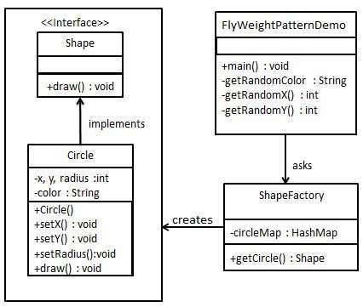

Step 1
Create an interface.
Shape.java
public interface Shape {
void draw();
}

Step 2
Create concrete class implementing the same interface.
Circle.java
public class Circle implements Shape {
private String color;
private int x;
private int y;
private int radius;

public Circle(String color){
this.color = color;
}

public void setX(int x) {
this.x = x;
}

public void setY(int y) {
this.y = y;
}

public void setRadius(int radius) {
this.radius = radius;
}

@Override
public void draw() {
System.out.println("Circle: Draw() [Color : " + color + ", x : " + x + ", y :" + y + ", radius :" + radius);
}
}

Step 3
Create a factory to generate object of concrete class based on given information.
ShapeFactory.java
import java.util.HashMap;

public class ShapeFactory {

// Uncomment the compiler directive line and
// javac *.java will compile properly.
// @SuppressWarnings("unchecked")
private static final HashMap circleMap = new HashMap();

public static Shape getCircle(String color) {
Circle circle = (Circle)circleMap.get(color);

if(circle == null) {
circle = new Circle(color);
circleMap.put(color, circle);
System.out.println("Creating circle of color : " + color);
}
return circle;
}
}

Step 4
Use the factory to get object of concrete class by passing an information such as color.
FlyweightPatternDemo.java
public class FlyweightPatternDemo {
private static final String colors[] = { "Red", "Green", "Blue", "White", "Black" };
public static void main(String[] args) {

for(int i=0; i < 20; ++i) {
Circle circle = (Circle)ShapeFactory.getCircle(getRandomColor());
circle.setX(getRandomX());
circle.setY(getRandomY());
circle.setRadius(100);
circle.draw();
}
}
private static String getRandomColor() {
return colors[(int)(Math.random()*colors.length)];
}
private static int getRandomX() {
return (int)(Math.random()*100 );
}
private static int getRandomY() {
return (int)(Math.random()*100);
}
}

Proxy Pattern
Simply, proxy means an object representing another object.
According to GoF, a Proxy Pattern "provides the control for accessing the original object".
So, we can perform many operations like hiding the information of original object, on demand loading etc.
Proxy pattern is also known as Surrogate or Placeholder.

Let's understand the example of proxy design pattern by the above UML diagram.

UML for Proxy Pattern:
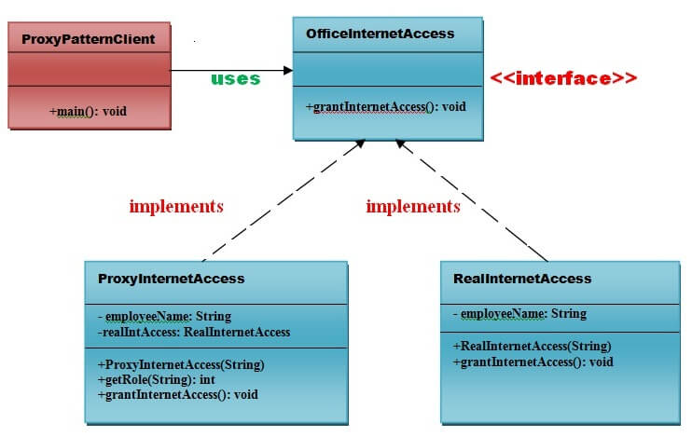

Implementation of above UML:

Step 1
Create an OfficeInternetAccess interface.
- public interface OfficeInternetAccess {
- public void grantInternetAccess();
- }

Step 2
Create a RealInternetAccess class that will implement OfficeInternetAccess interface for granting the permission to the specific employee.
File: RealInternetAccess.java
- public class RealInternetAccess implements OfficeInternetAccess {
- private String employeeName;
- public RealInternetAccess(String empName) {
- this.employeeName = empName;
- }
- @Override
- public void grantInternetAccess() {
- System.out.println("Internet Access granted for employee: "+ employeeName);
- }
- }

Step 3
Create a ProxyInternetAccess class that will implement OfficeInternetAccess interface for providing the object of RealInternetAccess class.
File: ProxyInternetAccess.java
- public class ProxyInternetAccess implements OfficeInternetAccess {
- private String employeeName;
- private RealInternetAccess realaccess;
- public ProxyInternetAccess(String employeeName) {
- this.employeeName = employeeName;
- }
- @Override
- public void grantInternetAccess()
- {
- if (getRole(employeeName) > 4)
- {
- realaccess = new RealInternetAccess(employeeName);
- realaccess.grantInternetAccess();
- }
- else
- {
- System.out.println("No Internet access granted. Your job level is below 5");
- }
- }
- public int getRole(String emplName) {
- // Check role from the database based on Name and designation
- // return job level or job designation.
- return 9;
- }
- }

Step 4
Now, Create a ProxyPatternClient class that can access the internet actually.
File: ProxyPatternClient.java
- public class ProxyPatternClient {
- public static void main(String[] args)
- {
- OfficeInternetAccess access = new ProxyInternetAccess("Ashwani Rajput");
- access.grantInternetAccess();
- }
- }

Behavioral Design Patterns

Behavioral design patterns are concerned with the interaction and responsibility of objects.
In these design patterns,the interaction between the objects should be in such a way that they can easily talk to each other and still should be loosely coupled.
That means the implementation and the client should be loosely coupled in order to avoid hard coding and dependencies.

Observer Pattern
An Observer Pattern says that "just define a one-to-one dependency so that when one object changes state, all its dependents are notified and updated automatically".

Benefits:
- It describes the coupling between the objects and the observer.
- It provides the support for broadcast-type communication.

Usage:
- When the change of a state in one object must be reflected in another object without keeping the objects tight coupled.
- When the framework we writes and needs to be enhanced in future with new observers with minimal chamges.

UML for Observer Pattern:
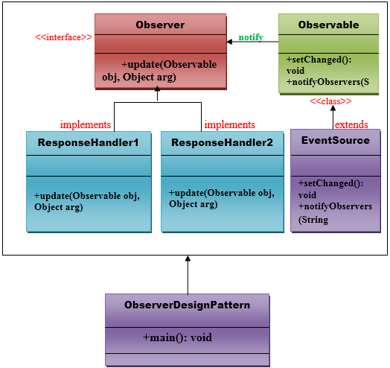

Implementation of Observer Pattern
Step 1:

Chain Of Responsibility Pattern
In chain of responsibility, sender sends a request to a chain of objects. The request can be handled by any object in the chain.
A Chain of Responsibility Pattern says that just "avoid coupling the sender of a request to its receiver by giving multiple objects a chance to handle the request". For example, an ATM uses the Chain of Responsibility design pattern in money giving process.
In other words, we can say that normally each receiver contains reference of another receiver. If one object cannot handle the request then it passes the same to the next receiver and so on.

- Components of the Observer Design Pattern
- Subject: The interface that defines methods for attaching, detaching, and notifying observers.
- ConcreteSubject: The class that implements the Subject interface and maintains the state of the subject.
- Observer: The interface that defines the method for updating observers.
- ConcreteObserver: The class that implements the Observer interface and gets updated by the ConcreteSubject.
- Example of the Observer Design Pattern in Java
Let’s create an example where a WeatherStation (subject) notifies different displays (observers) when the temperature changes.
- 1. Observer Interface
java
Copy code
public interface Observer {
void update(float temperature);
}
- 2. Subject Interface
java
Copy code
public interface Subject {
void attach(Observer observer);
void detach(Observer observer);
void notifyObservers();
}
- 3. ConcreteSubject Class
java
Copy code
import java.util.ArrayList;
import java.util.List;

public class WeatherStation implements Subject {
private List<Observer> observers;
private float temperature;

public WeatherStation() {
observers = new ArrayList<>();
}

@Override
public void attach(Observer observer) {
observers.add(observer);
}

@Override
public void detach(Observer observer) {
observers.remove(observer);
}

@Override
public void notifyObservers() {
for (Observer observer : observers) {
observer.update(temperature);
}
}

public void setTemperature(float temperature) {
this.temperature = temperature;
notifyObservers(); // Notify observers of the temperature change
}
}
- 4. ConcreteObserver Classes
java
Copy code
public class CurrentConditionsDisplay implements Observer {
private float temperature;

@Override
public void update(float temperature) {
this.temperature = temperature;
display();
}

public void display() {
System.out.println("Current conditions: " + temperature + "°C");
}
}

public class StatisticsDisplay implements Observer {
private float temperature;

@Override
public void update(float temperature) {
this.temperature = temperature;
display();
}

public void display() {
System.out.println("Statistics: Current temperature is " + temperature + "°C");
}
}
- 5. Client Code
java
Copy code
public class ObserverPatternExample {
public static void main(String[] args) {
WeatherStation weatherStation = new WeatherStation();

CurrentConditionsDisplay currentDisplay = new CurrentConditionsDisplay();
StatisticsDisplay statisticsDisplay = new StatisticsDisplay();

weatherStation.attach(currentDisplay);
weatherStation.attach(statisticsDisplay);

// Change temperature and notify observers
weatherStation.setTemperature(25.0f);
weatherStation.setTemperature(30.0f);
}
}
- Output:
mathematica
Copy code
Current conditions: 25.0°C
Statistics: Current temperature is 25.0°C
Current conditions: 30.0°C
Statistics: Current temperature is 30.0°C
- Explanation of the Code:
- Observer Interface:
  - The Observer interface defines a single method update(float temperature) that is called by the subject when the state changes.
- Subject Interface:
  - The Subject interface defines methods for attaching and detaching observers, as well as notifying them.
- ConcreteSubject Class (WeatherStation):
  - The WeatherStation class implements the Subject interface and maintains a list of observers.
  - It has a method setTemperature(float temperature) that updates the temperature and calls notifyObservers() to inform all registered observers about the change.
- ConcreteObserver Classes:
  - The CurrentConditionsDisplay and StatisticsDisplay classes implement the Observer interface.
  - Each observer updates its state and displays the current temperature whenever it receives a notification.
- Client Code:
  - The client creates a WeatherStation instance and two observer instances.
  - It attaches the observers to the subject and changes the temperature, which triggers notifications to the observers.
- Benefits of the Observer Design Pattern:
- Loose Coupling: Observers are loosely coupled to the subject. The subject doesn't need to know the specifics of the observers, only that they implement the Observer interface.
- Dynamic Relationships: Observers can be added or removed at runtime without modifying the subject.
- Multiple Observers: A single subject can have multiple observers, which can all be notified simultaneously.

Advantage of Chain of Responsibility Pattern
- It reduces the coupling.
- It adds flexibility while assigning the responsibilities to objects.
- It allows a set of classes to act as one; events produced in one class can be sent to other handler classes with the help of composition.
Let's understand the example of Chain of Responsibility Pattern by the above UML diagram.

UML for Chain of Responsibility Pattern:
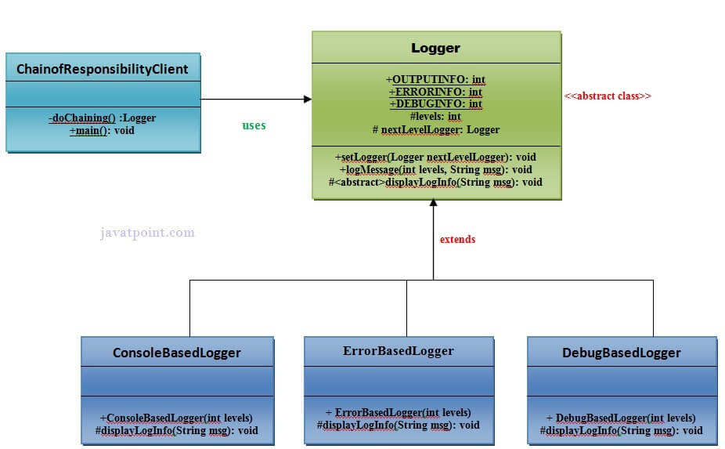

Implementation of above UML:

Step 1

// This object will contain 2 numbers and a
02 | // calculation to perform in the form of a String
03
04 | public class Numbers {
05
06 | private int number1;
07 | private int number2;
08
09 | private String calculationWanted;
10
11 | public Numbers(int newNumber1, int newNumber2, String calcWanted){
12
13 | number1 = newNumber1;
14 | number2 = newNumber2;
15 | calculationWanted = calcWanted;
16
17 | }
18
19 | public int getNumber1(){ return number1; }
20 | public int getNumber2(){ return number2; }
21 | public String getCalcWanted(){ return calculationWanted; }
22
23 | }

ADDNUMBERS.JAVA

01 | public class AddNumbers implements Chain{
02
03 | private Chain nextInChain;
04
05 | // Defines the next Object to receive the
06 | // data if this one can't use it
07
08 | public void setNextChain(Chain nextChain) {
09
10 | nextInChain = nextChain;
11
12 | }
13
14 | // Tries to calculate the data, or passes it
15 | // to the Object defined in method setNextChain()
16
17 | public void calculate(Numbers request) {
18
19 | if(request.getCalcWanted() == "add"){
20
21 | System.out.print(request.getNumber1() + " + " + request.getNumber2() + " = "+
22 | (request.getNumber1()+request.getNumber2()));
23
24 | } else {
25
26 | nextInChain.calculate(request);
27
28 | }
29
30 | }
31 | }

SUBTRACTNUMBERS.JAVA

01 | public class SubtractNumbers implements Chain{
02
03 | private Chain nextInChain;
04
05 | @Override
06 | public void setNextChain(Chain nextChain) {
07
08 | nextInChain = nextChain;
09
10 | }
11
12 | @Override
13 | public void calculate(Numbers request) {
14
15 | if(request.getCalcWanted() == "sub"){
16
17 | System.out.print(request.getNumber1() + " - " + request.getNumber2() + " = "+
18 | (request.getNumber1()-request.getNumber2()));
19
20 | } else {
21
22 | nextInChain.calculate(request);
23
24 | }
25
26 | }
27
28
29
30 | }

MULTNUMBERS.JAVA

01 | public class MultNumbers implements Chain{
02
03 | private Chain nextInChain;
04
05 | @Override
06 | public void setNextChain(Chain nextChain) {
07
08 | nextInChain = nextChain;
09
10 | }
11
12 | @Override
13 | public void calculate(Numbers request) {
14
15 | if(request.getCalcWanted() == "mult"){
16
17 | System.out.print(request.getNumber1() + " * " + request.getNumber2() + " = "+
18 | (request.getNumber1()*request.getNumber2()));
19
20 | } else {
21
22 | nextInChain.calculate(request);
23
24 | }
25
26 | }
27
28
29
30 | }

DIVIDENUMBERS.JAVA

01 | public class DivideNumbers implements Chain{
02
03 | private Chain nextInChain;
04
05 | @Override
06 | public void setNextChain(Chain nextChain) {
07
08 | nextInChain = nextChain;
09
10 | }
11
12 | @Override
13 | public void calculate(Numbers request) {
14
15 | if(request.getCalcWanted() == "div"){
16
17 | System.out.print(request.getNumber1() + " / " + request.getNumber2() + " = "+
18 | (request.getNumber1()/request.getNumber2()));
19
20 | } else {
21
22 | System.out.print("Only works for add, sub, mult, and div");
23
24 | }
25 | }
26 | }

TESTCALCCHAIN.JAVA

view source
print
?
01 | public class TestCalcChain {
02
03 | public static void main(String[] args){
04
05 | // Here I define all of the objects in the chain
06
07 | Chain chainCalc1 = new AddNumbers();
08 | Chain chainCalc2 = new SubtractNumbers();
09 | Chain chainCalc3 = new MultNumbers();
10 | Chain chainCalc4 = new DivideNumbers();
11
12 | // Here I tell each object where to forward the
13 | // data if it can't process the request
14
15 | chainCalc1.setNextChain(chainCalc2);
16 | chainCalc2.setNextChain(chainCalc3);
17 | chainCalc3.setNextChain(chainCalc4);
18
19 | // Define the data in the Numbers Object
20 | // and send it to the first Object in the chain
21
22 | Numbers request = new Numbers(4,2,"add");
23
24 | chainCalc1.calculate(request);
25
26 | }
27
28 | }

Template Pattern
A Template Pattern says that "just define the skeleton of a function in an operation, deferring some steps to its subclasses".

Benefits:
- It is very common technique for reusing the code.This is only the main benefit of it.

Usage:
- It is used when the common behavior among sub-classes should be moved to a single common class by avoiding the duplication.

UML for Template Pattern:
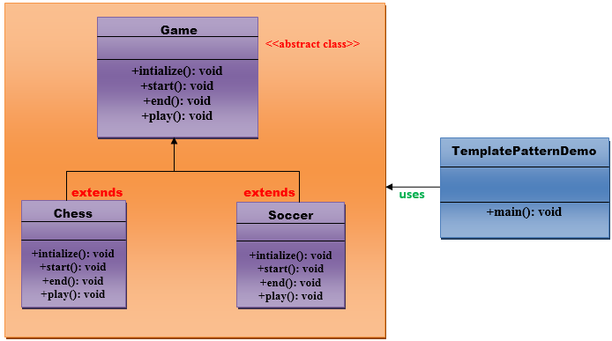

Implementation of Template Pattern:
Step 1:
Create a Game abstract class.
- //This is an abstract class.
- public abstract class Game {

- abstract void initialize();
- abstract void start();
- abstract void end();

- public final void play(){

- //initialize the game
- initialize();

- //start game
- start();

- //end game
- end();
- }
- }// End of the Game abstract class.
Step 2:
Create a Chess class that will extend Game abstract class for giving the definition to its method.
- //This is a class.

- public class Chess extends Game {
- @Override
- void initialize() {
- System.out.println("Chess Game Initialized! Start playing.");
- }
- @Override
- void start() {
- System.out.println("Game Started. Welcome to in the chess game!");
- }
- @Override
- void end() {
- System.out.println("Game Finished!");
- }
- }// End of the Chess class.
Step 3:
Create a Soccer class that will extend Game abstract class for giving the definition to its method.
ADVERTISEMENT
- //This is a class.

- public class Soccer extends Game {

- @Override
- void initialize() {
- System.out.println("Soccer Game Initialized! Start playing.");
- }

- @Override
- void start() {
- System.out.println("Game Started. Welcome to in the Soccer game!");
- }

- @Override
- void end() {
- System.out.println("Game Finished!");
- }
- }// End of the Soccer class.
Step 4:
Create a TemplatePatternDemo class.
- //This is a class.
- public class TemplatePatternDemo {

- public static void main(String[] args) throws InstantiationException, IllegalAccessException, ClassNotFoundException {

- Class c=Class.forName(args[0]);
- Game game=(Game) c.newInstance();
- game.play();
- }
- }// End of the Soccer class.

Strategy Pattern
A Strategy Pattern says that "defines a family of functionality, encapsulate each one, and make them interchangeable".

Benefits:
- It provides a substitute to subclassing.
- It defines each behavior within its own class, eliminating the need for conditional statements.
- It makes it easier to extend and incorporate new behavior without changing the application.

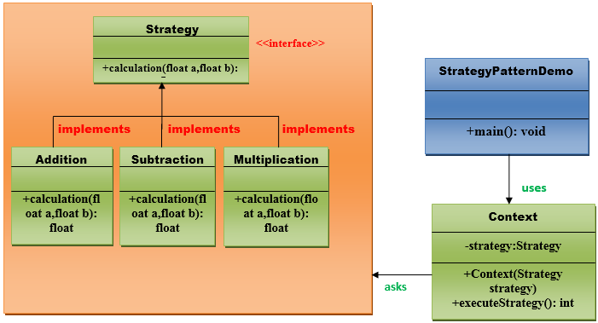

Implementation of Strategy Pattern:
Step 1:
Create a Strategy interface.
ADVERTISEMENT
- //This is an interface.

- public interface Strategy {

- public float calculation(float a, float b);

- }// End of the Strategy interface.
Step 2:
Create a Addition class that will implement Startegy interface.
- //This is a class.
- public class Addition implements Strategy{

- @Override
- public float calculation(float a, float b) {
- return a+b;
- }

- }// End of the Addition class.
Step 3:
Create a Subtraction class that will implement Startegy interface.
- //This is a class.
- public class Subtraction implements Strategy{

- @Override
- public float calculation(float a, float b) {
- return a-b;
- }

- }// End of the Subtraction class.
Step 4:
Create a Multiplication class that will implement Startegy interface.
- //This is a class.

- public class Multiplication implements Strategy{

- @Override
- public float calculation(float a, float b){
- return a*b;
- }
- }// End of the Multiplication class.
Step 5:
Create a Context class that will ask from Startegy interface to execute the type of strategy.
- //This is a class.

- public class Context {

- private Strategy strategy;

- public Context(Strategy strategy){
- this.strategy = strategy;
- }

- public float executeStrategy(float num1, float num2){
- return strategy.calculation(num1, num2);
- }
- }// End of the Context class.
Step 6:
Create a StartegyPatternDemo class.
- //This is a class.
- import java.io.BufferedReader;
- import java.io.IOException;
- import java.io.InputStreamReader;

- public class StrategyPatternDemo {

- public static void main(String[] args) throws NumberFormatException, IOException {

- BufferedReader br=new BufferedReader(new InputStreamReader(System.in));
- System.out.print("Enter the first value: ");
- float value1=Float.parseFloat(br.readLine());
- System.out.print("Enter the second value: ");
- float value2=Float.parseFloat(br.readLine());
- Context context = new Context(new Addition());
- System.out.println("Addition = " + context.executeStrategy(value1, value2));

- context = new Context(new Subtraction());
- System.out.println("Subtraction = " + context.executeStrategy(value1, value2));

- context = new Context(new Multiplication());
- System.out.println("Multiplication = " + context.executeStrategy(value1, value2));
- }

- }// End of the StrategyPatternDemo class.

